Client Portal 2.0

1. User Accounts and Login
- User Registration:
  - Clients sign up using their email and create a password.
  - An email verification is sent to confirm the account.
  - Optional: Add phone verification (OTP-based 2FA) for extra security.
- Login:
  - Secure login using email and password.
  - Option for Two-Factor Authentication (2FA) via email or SMS OTP.
- Password Reset:
  - Users can reset their password using email verification.

2. Onboarding Flow After Login
1️⃣ Welcome Screen
- A thank you message appears, welcoming the client.
- Briefly explain what to expect from working with CapitalQuest Funding.
- Next Button Message:
  - Button Label: “Next: Review & Sign Contract”
  - Message: "In the next step, you'll review and sign the contract, which outlines our agreement and how we will help you secure funding."
2️⃣ Contract Signing
- The client sees the contract on the screen.
- They can scroll, read, and digitally sign the contract.
- Next Button Message:
  - Button Label: “Next: Complete Your Onboarding”
  - Message: "Now that you've signed the contract, it's time to complete your onboarding form. This helps us gather the necessary details to begin your funding journey."
3️⃣ Onboarding Form
- The client is prompted to fill out the onboarding form with personal and business information.
- Final Message After Submission:

“Thank you! Your onboarding is complete. Our team will now review your details and update your progress inside the app. Stay tuned for updates!”

3. Client Dashboard (After Step 2 - Contract & Onboarding Complete)
Once the client completes the contract and onboarding form, they will be directed to the main dashboard of the portal. The dashboard will include the following key sections:
1️⃣ Progress Bar (Admin-Controlled Only)
- A visual progress bar displaying the client’s journey.
- Milestones: please refer to App
- Only the admin can update the progress bar based on the client’s progress.
2️⃣ Task Section
- A to-do list outlining what the client needs to complete in order for the next steps to proceed.
- The admin will manually update tasks and mark completed ones.
- Each client will have their own tasks
3️⃣ Funding Table
- Displays banks applied to, specific cards, application status (sent, pending, approved, denied), and total funding secured.
- Summary row at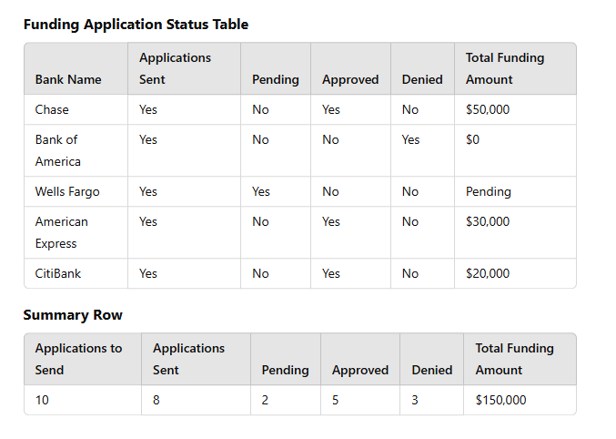 the bottom to show total funding progress.

4️⃣ Latest Documents Uploaded
- A section where clients can view the most recent documents uploaded by the admin.
- This allows clients to keep track of any important paperwork related to their credit repair or funding process.
5️⃣ Chat Bar (Direct Messaging Feature)
- A chat section where the client, Sam (Admin), and Ali (Admin) can communicate.
- Ensures real-time updates, document requests, and quick support.
📌 Note for Developer:
- Please refer to the provided video for the exact layout and user experience expectations.
- The admin should have full control over updates to the progress bar, tasks, funding table, and document uploads.

Updated Data Analyzer - Credit Report Overview

Key Features:
1️⃣ Credit Report Overview
- Total Hard Inquiries: Summary of all hard inquiries across Equifax, Experian, and TransUnion.
- Card Utilization: Detailed breakdown showing utilization per card.
- Overall Utilization: Displays the total utilization percentage across all accounts.
2️⃣ Credit Score Tracker
- Three Credit Scores: Equifax, Experian, and TransUnion scores displayed with updates.
- Score Change Graph: A visual graph that tracks credit score changes over time.
3️⃣ Milestone Tracking for Hard Inquiries
- Removed Hard Inquiries: Displays removed hard inquiries, including which bureau, which creditor, and the removal date.
- Visual Indicator: A color-coded system showing remaining vs. removed inquiries.
4️⃣ Utilization Breakdown
- Per Card Details: Displays creditor name, current balance, credit limit, utilization percentage, and new balance required (if the client needs to pay down the balance to reach the target utilization).
- Overall Utilization: Cumulative credit utilization ratio across all credit lines.
5️⃣ Insights & Recommendations (Task Section)
- All insights and recommendations will be given via the Task Section.
- Tasks will be manually assigned by the admin, ensuring personalized guidance on improving credit.
6️⃣ Credit Report Upload & Viewing
- Admin Upload Feature: I (admin) can upload the client’s full credit report downloaded from Experian.
- Integrated Document Viewer: Clients can view their credit report directly in the app in a clear and structured format.
📌 Developer Notes:
- Please refer to the video, specifically the Notion section, where I have already set up the credit information layout.
- I want the app’s credit report section to match or be even better than what I built in Notion.
- Ensure a seamless document viewing experience for uploaded credit reports within the app.
- I also have the forms ready when you want to connect them to the app and the contracts

